BRITISH SCHOOLSCYCLING ASSOCIATION NATIONAL AND REGIONAL CIRCUIT CHAMPIONSHIPS
Welcome to BSCA’s national circuit race.
Before BC (British Cycling) there was BSCA run by volunteers to provide racing and championships for children racing for their school. It is still part of the cycling scene run by a small group of dedicated volunteers.
Here are the ‘need to knows’ for the event

THIS EVENT WILL BE RUN UNDER BRITISH CYCLING RULES as it is a collaboration between BSCA and BC as a test event partnership.

Venue:
Hammerstones Cycle Circuit
Hammerstones Leach Lane,
Elland
HX5 0QP

PARKING:
Brooksbank School,
Victoria Road
Elland
HX5 0QG
Directions from the M62 to Brooksbank School
Travelling from Manchester – Exit Junction 24 M62, turn left at the roundabout. **Descend Blackley Road to the crossroads at the bottom of the hill. Turn right onto Victoria Road, go past the first school gates and turn right into the second to park at the front of the school.
Travelling from Leeds, exit at Junction 24 , go down to the roundabout, turn back on yourself to go back up towards the motorway. Do not tun onto the motorway but go past to the roundabout and take first left down Blackley Road then follow the directions from ** above.
To get to the circuit, turn left out of the school, straight ahead at the Blackley Road junction and the entrance to the circuit is on the right through gates in a wall. If you are dropping off equipment, please be mindful of traffic on the road and people entering and leaving the circuit.
EVENT TIMINGS:
Sign On opens at 12.30. Please get your gears checked first. There will be help if you need it. Once your gears are cleared, you can sign on. Non BSCA members will be asked to pay a day licence of £1.50. Please bring correct change.
SCHOOLS INFO At sign on, please complete the schools column next to your name.
Start Race
13:30 BSCA U7 National Championships Born on or after 01/09/2014
13:50 BSCA U9 National Championships Born 01/09/2012-31/08/2014
14:10 BSCA U11 National Championships Born 01/09/2010-31/08/2012
14:40 BSCA U13 Boys National Championships Born 01/09/2008-31/08/2010
15:20 BSCA O15 Girls National Championships Born 01/09/2002-31/08/2006
15:20 BSCA U13 Girls National Championships Born 01/09/2008-31/08/2010
15:20 BSCA U15 Girls National Championships Born 01/09/2006-31/08/2008
16:10 BSCA O15 Boys National Championships Born 01/09/2002-31/08/2006
16:10 BSCA U15 Boys National Championships Born 01/09/2006-31/08/2008
17.00 Women’s 2,3,4 Enter on the day.
TIMING CHIPS
Once signed on, you will receive a timing chip and number. The chip is placed on your left front fork, low down. The number is to be pinned so it is at the lower back, slightly to the right hand side.
THE TIMING CHIP MUST BE RETURNED AT THE END OF YOUR RACE. A CHARGE OF £90 WILL BE MADE IF YOU LEAVE WITHOUT HANDING IT IN. There will be chip collectors as you leave the circuit.
You will be racing in a clockwise direction. When the leader in on the final lap, you will hear a bell (unless the leader laps you twice in the final lap). As the race finishes, continue past the finish line for three quarters of a lap and then exit the circuit via the path by the building.
There will be a tuck shop with snacks and cakes etc run to raise funds for a scouts exhibition.
PODIUM
There are medals for top three in each race and a winner’s badge separate for boys and girls once the results are finalised aiming to be held within half an hour after each race. The National result will be first followed by the Yorkshire regional.
The Commissaires Decision is final.

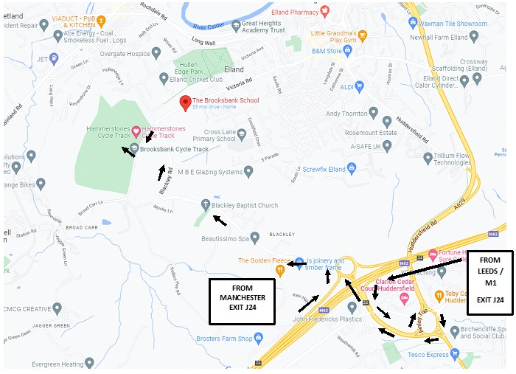
Enjoy the Racing!

Entrant List:

