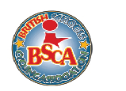
BSCA WEST MIDLANDS REGIONAL GRASS TRACK CHAMPIONSHIPS 2022
Saturday 9th July
Bishop Challenor & Queensbridge Playing fields
Moor Green Lane Birmingham B13 8NE
Information for riders and their helpers
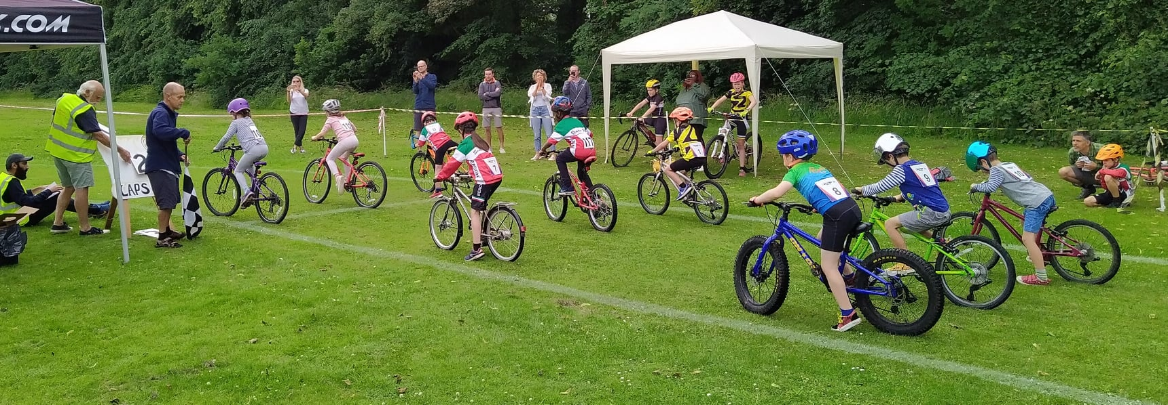

Welcome
Thank you for entering the 2022 West Midlands Grass Track Championships. We at Beacon Cycling Academy are really pleased to be back at Queensbridge. It is really great to be working with Queensbridge and Bishop Challenor schools and our sincere thanks go to staff and governors who have made this possible. The event will bring together young riders with prior experience and many who are racing for the very first time. We hope all of them will have an enjoyable afternoon. We would like to emphasise to all of our riders that regardless of their final position in the races, if they have challenged themselves and tested their skill and stamina they will have succeeded. We need to be prepared for all eventualities – so in the event of a cancellation you will receive this information via the e-mail you have provided on Eventbrite. Whilst we very much hope this will not be necessary, our risk assessment is based on the British Cycling Event Planning tool. Please do not attend if you have Covid19 symptoms. The event is open only to riders who have pre entered. There will be no entry on the line so if you know anyone who wants to take part, please encourage them to book on in order to avoid disappointment.
Programme
U7 (school years 1 and 2) - race start 11:00
U9 (school years 3 and 4) - race start 12:30
U11 (school years 5 and 6) - race start 14:00
U13 (school years 7 and 8) - race start 15:30
Please allow 20 – 30 minutes before your race starts for signing on.
Riders will have access to a dedicated warm up area. Please ensure that your rider understands that they should only ride in the designated space. Rides will need to remain alert for announcements and it is their responsibility to arrive at the start line ready for their races.

Events
Riders will compete in several races against other competitors in their age category. Medals will be awarded to the three highest placed boys and girls in each age group. In addition, the highest placed boy and girl in each age group will receive a regional champion’s sew on patch. Points will be awarded for each of the three events (see below) and added to give an overall total.
Event 1: Time Trial. U7 & U9 100m U 11 & U13 200m. Riders race individually against the clock. They have a ‘flying start.’ The distance over which they are timed will be indicated by a green flag at the start and a checkered flag at the end. The timing for this event will be used to determine the heats for event 2 and gridding for event 3.
Event 2: Sprint. Two or three riders will take to the start line in a series of heats. They will need a helper to hold them steady on the start line. U7s will race for one lap (250m). U9s U11s and U13s will race for two laps (500m). The first rider over the line will qualify for the next round. Riders who do not win their heat will have an opportunity to qualify through a repechage race. The winning semi-finalists will qualify for the final. The losing semi-finalists for a 3rd & 4th place decider.
Event 3: Scratch race. All riders take to the start line at the same time. They will be gridded based on their time in the time trial with the fastest three riders on the front row. U7s will race for one lap (250m). U9s will race for two laps (500m). U11s will race for three laps (750m) and U13s will race for four laps (1000m). A lap board will indicate the number of laps left to the riders and a bell will sound to indicate one lap to go. The number of laps to go will be guided by the position of the lead rider.

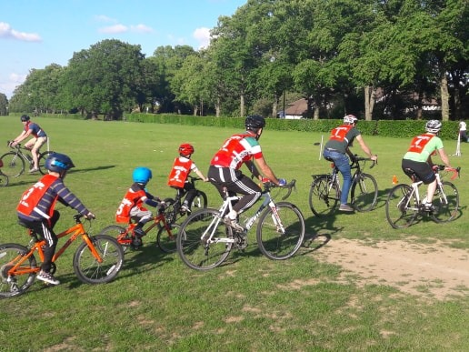
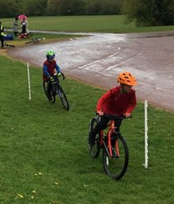 | 
Before the day of the race
It is the parent’s/carer’s responsibility to ensure that their young rider’s bike is safe and in good working order. A guide is here if you are unsure https://www.sustrans.org.uk/our-blog/get-active/2019/everyday-walking-and-cycling/the-m-check-for-your-bike-in-11-steps Tyres must be suitable for grass. That means a tread deep enough so that you can insert a 5p coin to the dotted line. Please check this in advance to avoid disappointment on the day.
It is also the parent’s/carer’s responsibility to ensure that their young rider has a helmet that fits properly https://www.youtube.com/watch?v=wG7Bj-E8fs8

Venture Bikes in Stirchley are offering 30% off the cost of a service for competitors. Simply show your Eventbrite ticket when booking to receive the discount.
You must self –assess for Covid 19 symptoms; yourself, your young rider and any helper.

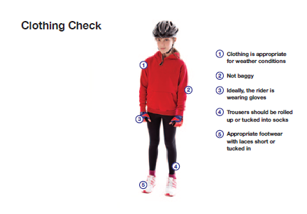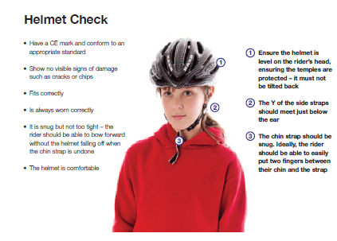

Getting there
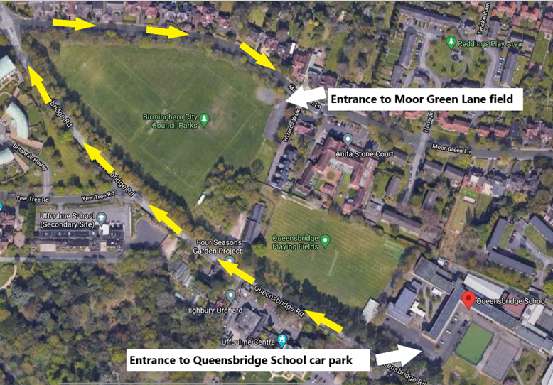 | 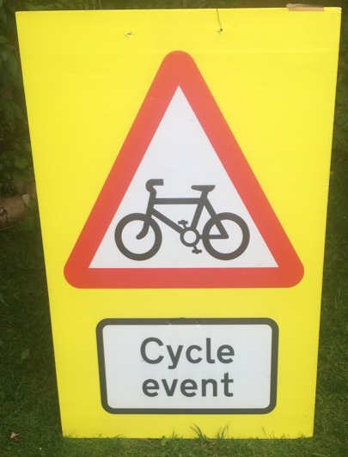

The entrance to the field is on Moor Green Lane which is some distance from the main Queensbridge School Entrance. Moor Green Lane is strange and undertakes several right angled turns. Aim for Wizards Walk (yes really!) and look out for the Cycle event sign.
The field is situated close to National Cycle Route 5. From there Holders Lane, Moor Green Lane and Yew Tree Rd are all relatively quiet and have 20mph speed limits in place. Take care if using the Moor Green Lane/Russell Rd/Reddings Rd roundabout.
Limited parking is available. This must be booked via the add-on facility in Eventbrite. If you have booked parking, please e-mail your registration number to academy@beaconrcc.org.uk a space will be reserved for you.

On the day
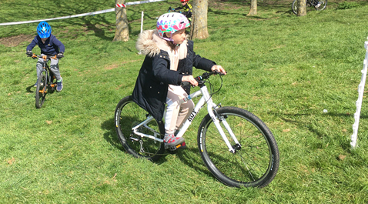 | 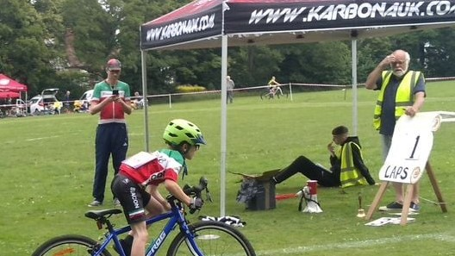

Please make sure that you have everything you need. There will be an ice cream van but that’s almost certainly best after the race. You’ll need food (bananas are good) and drink (water). We can’t share equipment so think about bringing your own tools/ spares. Please bring your own pen and hand sanitizer. The event takes place outdoors so masks will not need to be worn. There is a toilet facility indoors and adults are asked to wear masks when using these facilities.
Allow time for signing on. Riders and their parents need to sign on for legal reasons and to say they will stick to the rules.
I agree to abide by BSCA rules and understand and agree that I participate in this race entirely at my own risk, that I must rely on my ability in dealing with all hazards, and that I must ride in a manner which is safe for myself and all others. I am aware that when riding, I must decide whether the movement is safe. I agree that no liability whatever shall attach to the promoter, promoting club (Beacon RCC) , or member of the promoting club in respect of any injury, loss or damage suffered by me, in or by reason of the race, however caused.
Riders can then collect their race numbers which will need to be returned to the signing on desk after their racing has finished. Helpers will also be asked to sign in for contact tracing.

During the racing
All riders and spectators are asked to keep 3m from the track edge whilst racing is in progress. The track should not be crossed anywhere apart from at the designated crossing point. Permission must be asked from a marshall prior to crossing the race track. Riders should listen carefully for announcements and be at their start line ready for their event.
Riders, spectators, parents/carers
This applies to individuals participating in and/or spectating cycling within the club environment or competitive sport, or as a recreational activity, including parents/carers of those involved in cycling activity.
These individuals will, at all times:
• take responsibility in ensuring that they are up-to-date with the rules for their cycling discipline, understand and adhere to them and encourage others to do the same;
• recognise and respect the valuable contribution made by all riders, coaches, officials, ride leaders and volunteers;
• respect officials and publicly accept their decisions;
• respect the school fields by not littering and by maintaining proper personal behaviour;
• remember that all riders gain a wide range of benefits from participating in cycling, and the sport is not just about winning and losing; and
• provide encouragement and support to all participants, recognising that we all make mistakes.

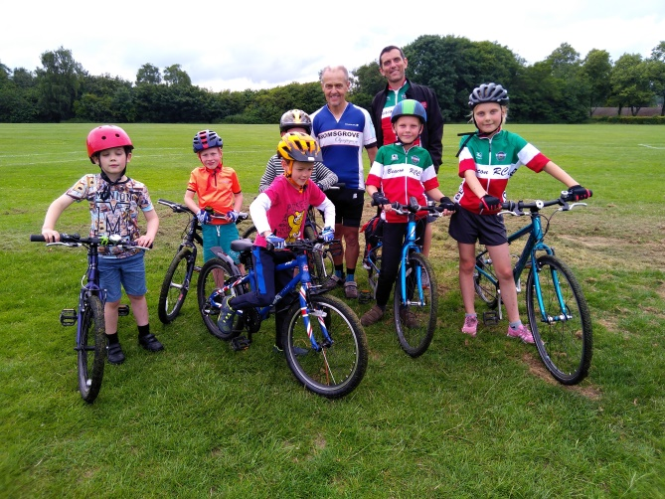

After the racing
Prizes will be made available to the first three riders in a designated area. Distancing requirements rule out a traditional podium presentation but riders will be able to collect their medals/ patches on the day. Participants and helpers are asked to maintain social distancing after the event. In the event that riders or their helpers experience covid symptoms after the event then academy@beaconrcc.org.uk should be contacted so that others can be notified promptly.

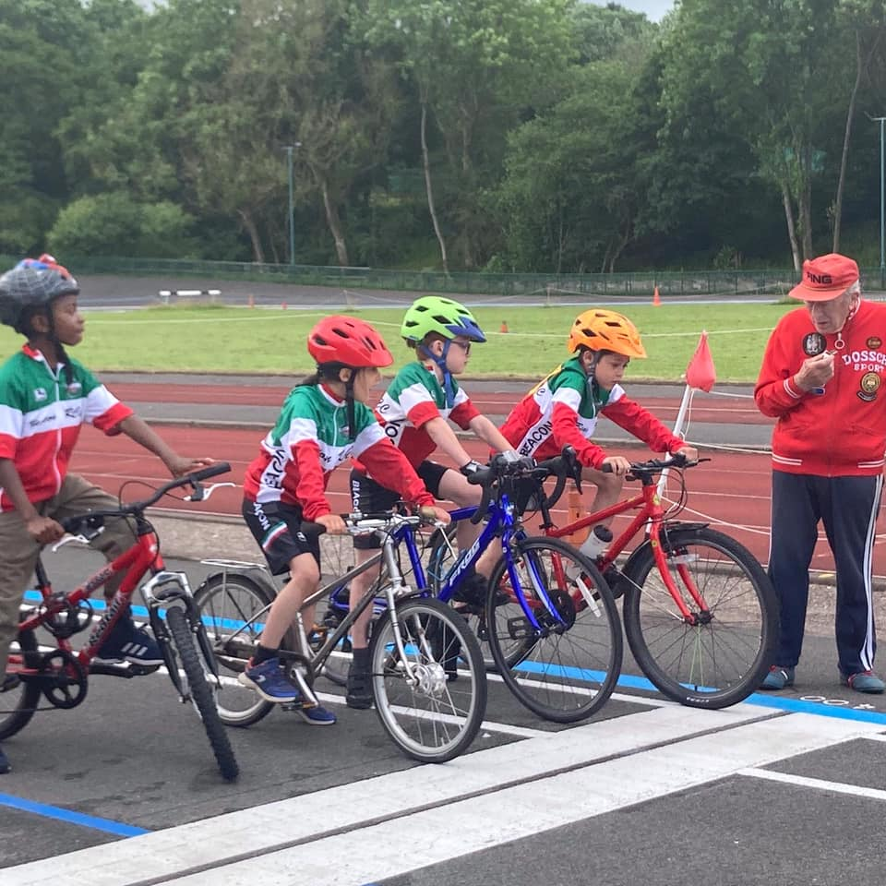
Safeguarding
The club’s welfare officer is Kate Dighton who can be contacted via welfare@beaconrcc.org.uk if you have any concerns.

Photography
Please ask when signing on about the consent of other competitors for photography in your child’s race. The club has a social media hashtag #beaconrcc75 for events relating to its 75th anniversary.
Taking it further
If your young rider has enjoyed the event and would like to continue having fun on their bike and developing their skills & fitness, we provide regular coaching/ training events in Central/South Birmingham. You can follow us on Facebook @beaconcyclingacademy or www.beaconrcc.org.uk/academy if you are members of other clubs or have a range of other hobbies we would still be delighted to see you at our future events.
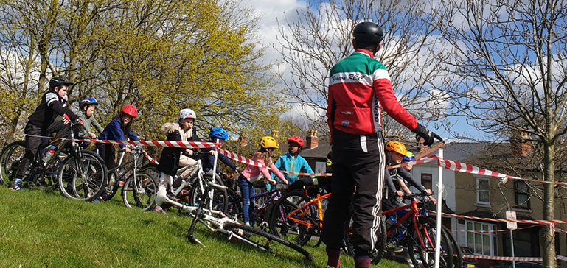 | 