BRITISH SCHOOLS CYCLING ASSOCIATION
NATIONAL HILL CLIMB CHAMPIONSHIPS

Event: Schools National Hill Climb

Organisers: Solent Pirates Youth Cycling Club, Team Axiom & Ditcham Park Cycling Club

Contact: David Morgan – davemorgan99@icloud.com - Mobile: 07976 976218

Promoted by: Solent Pirates Youth Cycling Club (SPYCC)

Event Website: Eventbrite - https://www.eventbrite.co.uk/e/british-schools-cycling-association-national-hill-climb-tickets-57409951711

Location: Ditcham Park School

Date: 15th June 2019

Time: Registration 0745 – 0945
Race 1000 – 1330.

Categories: U7/U9/U11/U13/U15/O15

Where to find us:

It’s important that all attendees and competitors use the south drive entrance via Chalton village (PO8 0BG) to allow for the course to be reviewed and prepared for the morning racing. The school is sign posted from Chalton village. (School post code - GU31 5RN) From the south/north (A3) take the exit towards Butser Hill/Hambledon/East Meon, Turn right onto Chalton Lane, at the roundabout take the 2nd exit and stay on Chalton Lane.

Entrance Via (South Drive Only)

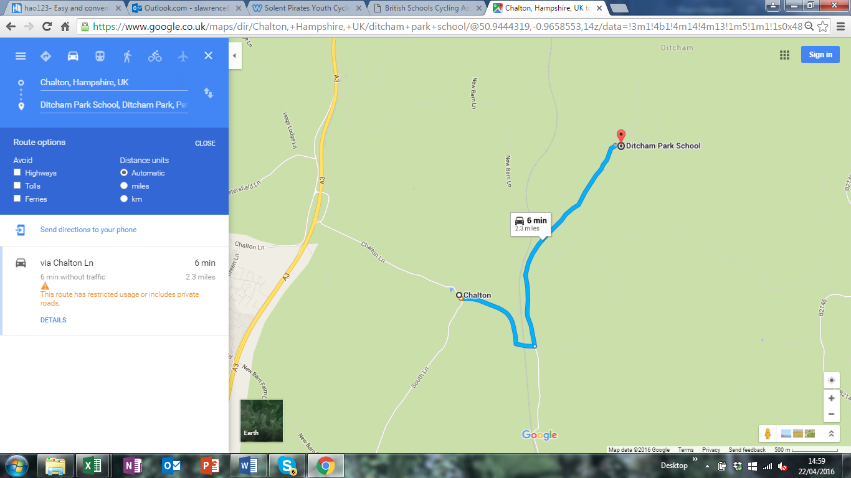
South Drive

Competitors Information

- Registration will be held in the Gym building on the first floor between 0745 to 0945. All registration to be completed by 0945, prior to first start.

- Collect your race number and approx. start time. Keep hold of your race number as you’ll be able to use this to obtain a free hot dog from the BBQ.

- Bring your B.S.C.A membership card and produce it when you sign on or you will be charged a £2 day licence if you can’t provide proof of membership on the day. If you don’t have a card, proof of your affiliated club membership or private membership will be required.

- Start times are only guidelines and may be subject to change, ensure you are ready.

- Top three boys and girls will receive a medal and a certificate.

- All bikes must be in full working order and must have brakes.

- Girls will be started just after the boys in each age category.

- Children competing in the National Championships must compete in the events by their own efforts. We allow parents/guardians to ride/run behind the U11 riders however no physical assistance or verbal guidance can be given.

- Please stay clear of riders on their Hill Climb when riding down to your start. At no time is anyone allowed to impede the progress of another rider.

- Allow a good 10 minutes to roll down to the start line. The U9 to U11 will be escorted.

- The course will be well marshalled, for your information a local half marathon is taking place during the event however we are managing both events.

- Club Tents & Gazeebos: We would really appreciate your support in helping us to achieve a more social area by centralising all the schools club tents and gazeebos, outside of the Gym building, on the edge of the sports field.

- Welfare: Changing facilities, toilets and refreshments will be available within the main Gym building. We are also planning a BBQ at the end of the event.

