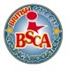

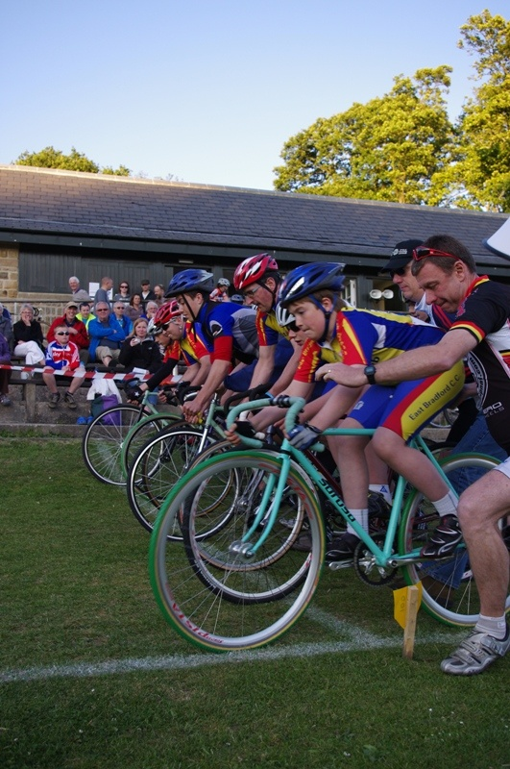
THE BRITISH SCHOOLS NATIONAL GRASS TRACK CHAMPIONSHIPS 2017/2018
Racing Starts at 13.00
Signing On closes at 12.45
SATURDAY

PROMOTED BY

WEST RIDING TRACK LEAGUE
AND
EAST BRADFORD CC

ENTRANTS
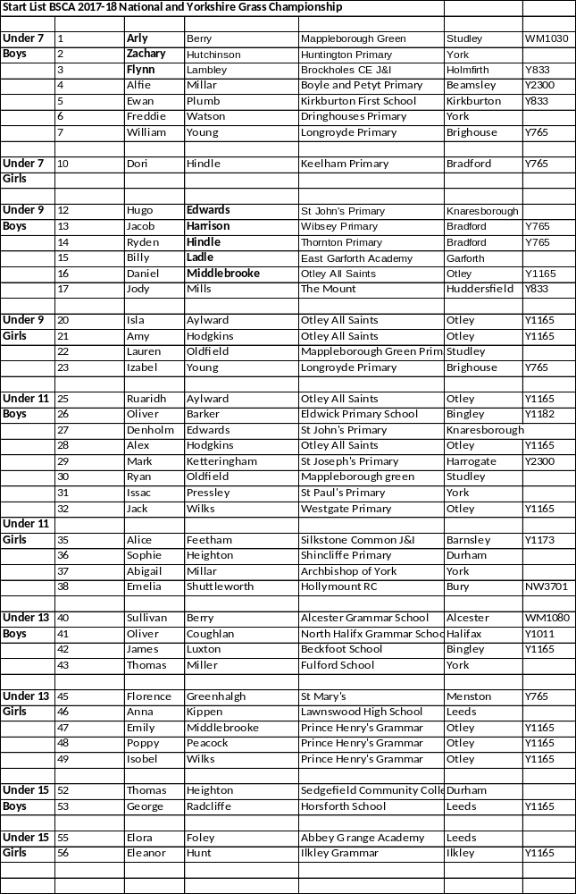
Location, Parking and Facilities
York Racecourse , Tadcaster Road, York YO23 1EX
Parking will be in the main event car park and not trackside due to movement restrictions on site.
Website: https://britishschoolscyclingassociation.com/
Facebook: https://www.facebook.com/groups/147830038567853/?ref=group_headerIn Person: By telephone: Tel:07917 860292
By email: mandyparker2@ntlworld.com
By post: Mandy Parker, 22 Airedale Gardens, Leeds, LS13 1DN

ADMINISTRATION

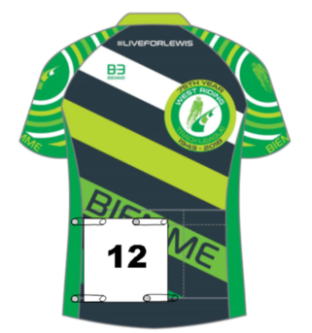
Signing On will be in the tent at the side of the arena. It will open at 12 noon and close for all age categories at 12.45 for the first event to start at 13.00.
Riders will need to pass a gear check first before signing on.

Number Placement
(Rear of Jersey)

RIDER INFORMATION

The championship is under the British Schools Cycling Association Rules which can be found on the website at: http://www.bsca.org.uk/

No entry on the day for the National/Regional Championship. Time permitting there may be Come and Try it Events.

This event will run until LATE afternoon with three counting events. There will be a break n the programme at 15pm for a parade around the arena.
FOR AGE CATEGORIES UNDER 7/9/11/13/15/OVER 15

(AGE ON 1ST SEPTEMBER 2017)
UNDER 13’S AND BELOW USE FREEWHEEL BIKES IN GOOD WORKING ORDER e.g. Mountain bikes or Cyclo-Cross Bikes WITH MOUNTAIN BIKE OR CYCLO-CROSS TYPE TYRES (NO SMOOTH/ROAD TYRES**)
UNDER 15’S/OVER 15’S USE FIXED WHEEL TRACK BIKES WITH MOUNTAIN BIKE OR CYCLO-CROSS TYRES (NO SMOOTH OR ROAD TYRES**)
**TYRES WITH SIMILAR LIGHT TREADS SUCH AS THE Challenge Strada Bianca Open Tubular Tyre are NOT Suitable.)
All Tyres must have a clearly visible tread and not just be a grippy road bike tyre.

COMMISSAIRES DECISION WILL BE FINAL ON SUITABILITY OF TYRES

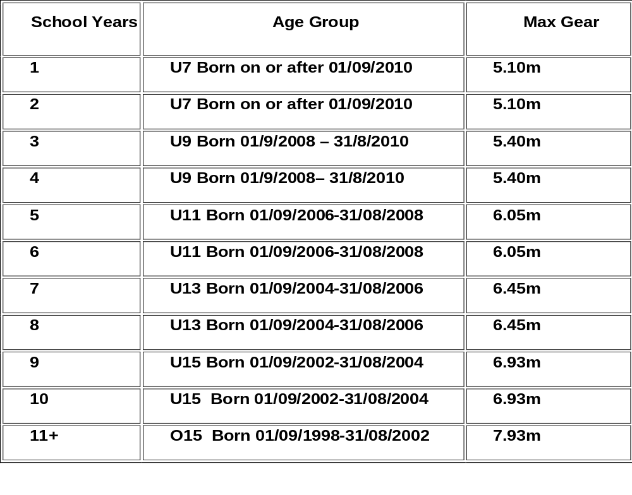

Riders born before 1st September 1999 are not eligible.

The Riders must compete by their own efforts. The Heats etc may change depending on numbers signing on.

The championship is in the form of an omnium consisting of three counting events, a sprint, a time trial or pursuit and a scratch race. Proposed points for Youth Omnium:1 for 1st then ,2,3,4,5,6,7etc, lowest points win. In case of a tie for the Youth event we will go back to the Scratch results, If still tied, back to time trial/ pursuit time.

Triathlon bars and Spinache style bar extensions are not permitted in any BSCA Massed start events. Spinache bars are not allowed in any event.

Aero style helmets are not to be used in mass start events.

Please do not cross the track while racing is in progress.
EVENT PROGRAMME
AT 3PM THERE WILL BE A SHORT BREAK IN OUR PROGRAMME
Officials Briefing at 12.50
BSCA National Grass Championship Signing On Starts 12 and Closes at 12.45

Event 1 BSCA Sprints Prompt Start at 13.00
(Omnium 1 of 3)
Event 1 Under 7 Boys Straight Final
Final | 1 | 2 | 3 | 4 | 5 | 6 | 7

Event 2 Under 7/9 Girls Straight Final - No 1 is in a separate competition.
Final | 10 | 20 | 21 | 22 | 23

Event 3 Under 9 Boys Straight Final
Final | 12 | 13 | 14 | 15 | 16 | 17

Event 4 Under 11 Girls Straight Final
Final | 35 | 36 | 37 | 38

Event 5 Under 11 Boys First 3 Through to the Final, remaining to Minor Final.
Heat 1 | 25 | 27 | 29 | 31
Heat 2 | 26 | 28 | 30 | 32

Event 6 Under 13 Straight Final – separate points for each category
Final | 45 | 46 | 47 | 48 | 49

Event 7 Under 13 Boys Straight Final
Final | 40 | 41 | 42 | 43

Event 8 Under 15 Boys/Under 15 Girls Straight Final – separate points for each category
Final | 52 | 53 | 55 | 56

Minor Final
Result
Event 9 Under 11 Boys Finals

Final
Result

Event 10 1 Lap Time Trials for U7 Boys and Girl (Omnium 2 of 3)
Line up in Number Order just off the start line.
Event 11 - FOUR STATION PURSUIT (Omnium 2 of 3)
The pursuit heats will have up to four riders on the track at once, riding the number of laps for their age group. If the heat is three laps, each rider will ride from their station until they complete the correct number of laps returning to their start position.

Please ensure all youth riders are in their waiting areas (WA) when this event is announced.

PURSUIT STATIONS

 |  | PURSUIT STATION HEATS
Heat | No of Laps | Age Cat | Station 1 | Station 2 | Station 3 | Station 4
1 | 3 | U9B | 12 | 13 | 14
2 | 3 | U9B | 15 | 16 | 17
3 | 3 | U9G | 20 | 21 | 22 | 23
4 | 5 | U11B | 25 | 26 | 27 | 28
5 | 5 | U11B | 29 | 30 | 31 | 32
6 | 5 | U11G | 35 | 36 | 37 | 38
7 | 5 | U13B | 40 | 41 | 42 | 43
8 | 5 | U13G | 45 | 46 | 47
9 | 5 | U13G | 48 |  | 49
10 | 6 | U15B | 52 | 53
11 | 6 | U15G | 55 | 56

Map of Track for Pursuit Stations There will be coloured flags to denote stations

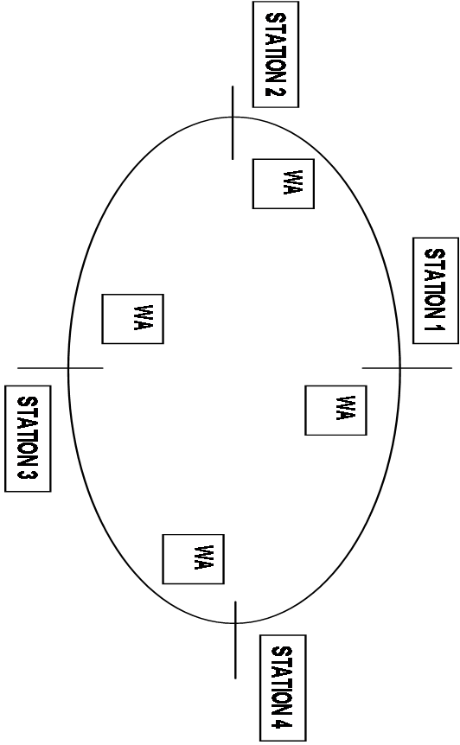
Scratch
START/FINSIH LINE

BSCA Youth Scratch Race – Rolling Start (Omnium 3 of 3)

Event 12 | U7 Boys/Girls | 2 Lap
Event 13 | U9 Boys | 3 Laps
Event 14 | U9 Girls | 3 Lap
Event 15 | U11 Boys | 5 Laps
Event 16 | U11 Girls | 5 Laps
Event 17 | U13 Boys | 5 Laps
Event 18 | U13 Girls | 5 Laps
Event 19 | U15 Boys / U15 Girls | 6 Laps

Fun Races depending on time while results are being calculated.

Prize Presentation and Close

