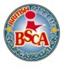
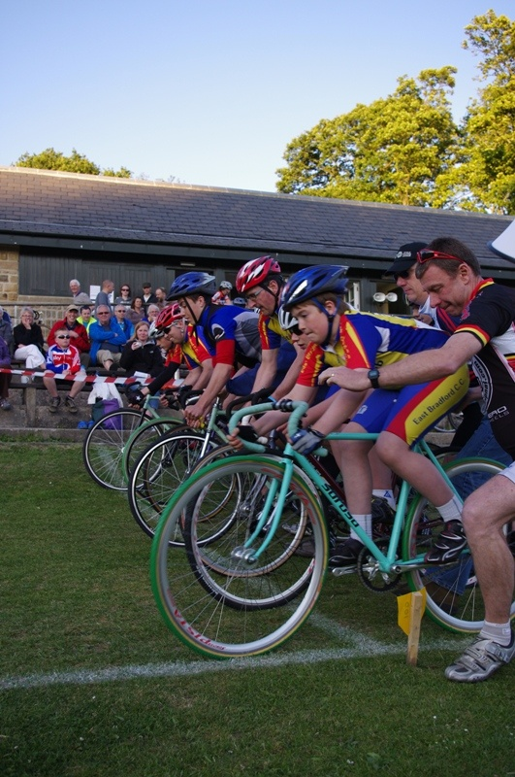
THE BRITISH SCHOOLS NATIONAL GRASS TRACK CHAMPIONSHIPS 2016/2017
Saturday 24th June 2017
Racing Starts at 12.30
Signing On is from 11.15 and closes at 12.15
PROMOTED BY

WEST RIDING TRACK LEAGUE
AND
EAST BRADFORD CC

ENTRANTS
Number | Surname | First name | School | Town
Under 7
1 | Harrison | Jacob | Wibsey Primary | Wibsey
2 | Holland-Leader | William | St.Edmund's Catholic | Godalming
3 | Ladle | Billy | East Garforth Primary | Garforth
4 | Millar | Angus | Boyle and Peyyt | Skipton
5 | Millar | Alfie | Boyle and Peyyt | Skipton
6 | Young | William | Longroyde Primary | Brighouse
10 | Aylward | Isla | Otley All Saints | Otley
11 | Sobo-Allen | Maisie | Brockholes Cof E I & J | Homfirth
Under 9
15 | Aylward | Ruaridh | Otley All Saints Primary | Otley
16 | Denwood | Cormac | Rossett Acre Primary | Harrogate
17 | Denwood | Magnus | Rossett Acre Primary | Harrogate
18 | Edwards | Hugo | Knaresborough St.John's | Knaresborough
19 | Hindle | Ryden | Keelham Primary | Bradford
20 | Ketteringham | Mark | St.Josephs Primary | Harrogate
21 | Middlebrooke | Daniel | Otley All Saints Primary | Otley
22 | Mills | Jody | The Mount | Huddersfield
23 | Wilkinson | Ewen | Harden Primary | Bingley
25 | Chambers | Annie | The Whartons | Otley
26 | Chambers | Charlotte | The Whartons | Otley
27 | Hodgkins | Amy | Otley All Saints | Otley
28 | Oldfield | Lauren | Mappleborough Green | Studley
29 | Peacock | Amber | The Whartons | Otley
30 | Thompson | Sian | Eastburn J & I | Keighley
31 | Young | Izabel | Longroyde Primary | Brighouse
Under 11
35 | Edwards | Denholm | Knaresborough St.Johns | Knaresborough
36 | Hodgkins | Alex | Otley All Saints | Otley
37 | Krasinski | Euan | Talbot Primary | Leeds
38 | Scott-Wright | Noah | Willow Green Academy | Ferrybridge
39 | Thomas | Ryan | Queensway Primary | Yeadon
40 | Wilks | Jack | Westgate Primary | Otley
45 | Greenhaigh | Florence | SS Peter and Paul | Leeds
46 | Heighton | Sophie | Shincliffe Primary | Durham
47 | Middlebrooke | Emily | Otley All Saints | Otley
48 | Moncrieffe | Rose-Marie | The Cottage School | Chichester
49 | Peacock | Poppy | The Whartons | Otley
50 | Wilkinson | Megan | Harden Primary | Bingley
51 | Wilks | Isobel | Westgate Primary | Otley
Under 13
55 | Brookes | Joseph | Redhill School | Stourbridge
56 | Heighton | Thomas | Sedgefield Community College | Sedgefield
57 | Radcliffe | George | Horsforth School | Leeds
58 | Sansom | Mark Ashely | Guiseley High School | Leeds
59 | Thompson | Owen | South Craven | Keighley
Under 15
65 | Davison | Liam | Garforth Academy | Leeds
66 | Krasinski | Max | Roundhay High Schools | Leeds
70 | Hunt | Eleanor | Ilkley Grammar | Ilkley

Location, Parking and Facilities
York Race Course, Knavesmire, Tadcaster Road, York YO23 1EX
Follow the marshals directions for day parking unless you are camping. The event is held in the event arena and signing on will be in the large tent next to the arena itself.
Website: www.westridingtrackleague.com
Facebook: https://www.facebook.com/groups/106258202741389/
In Person: By telephone: Tel:07917 860292
By email: mandyparker2@ntlworld.com By post: Mandy Parker, 22 Airedale Gardens, Leeds, LS13 1DN

ADMINISTRATION

First Aid is provided by the The York Rally organisers. There will be food stalls on site and changing facilities as well as lots of other events over the weekend including an arena cross on the Sunday.

The York Rally Site is at: http://yorkrally.org/

RIDER INFORMATION

• The championship is under the rules of the British Schools Cycling Association Rules which can be found on the website at: http://www.bsca.org.uk/. There are additional rules as outlined below set by the organiser for the safety of the riders.

• No entry on the day for the National .
• For the BSCA competition U7,U9,U11 and U13 riders must use freewheel bikes in good working order with tyres with cyclo-cross tyres or MTB tyres.
U15/O15 must use track bikes with lock rings and no brakes and grass track/ cyclo-cross type tyres – no slicks and no quick release skewers.
All Tyres must have a clearly visible tread and not just be a grippy road bike tyre.
The reason for this is if it is damp on the grass from dew or if it rains, tyres must be able to grip the surface to prevent accidents.
Bikes will be checked by the Commissaires on the morning of the event and any bike not deemed suitable will not be allowed to take part.

The
• Riders must compete by their own efforts. The Heats etc may change depending on numbers signing on.

• The championship is in the form of an onmium consisting of three counting events, a sprint, a time trial or pursuit and a scratch race. Proposed points for Youth Omnium:1 for 1st then ,2,3,4,5,6,7etc, lowest points win. In case of a tie for the Youth event we will go back to the Scratch results, If still tied, back to time trial/ pursuit time.

• Triathlon bars and Spinache style bar extensions are not permitted in any BSCA Massed start events. Spinache bars are not allowed in any event.

• Aero style helmets are not to be used in mass start events.

Please do not cross the track while racing is in progress.
EVENT PROGRAMME
Officials Briefing at 10.15
BSCA National Grass Championship Signing On Starts 11.15am and Closes at 12.15pm
PLEASE PRESENT YOUR BIKE TO THE COMMISSAIRE BEFORE SIGNING ON FOR CHECKING

Event 1 BSCA Sprints Prompt Start at 12.30am
(Omnium 1 of 3)
Event 1 Under 7 Boys Straight Final
Final | 1 | 2 | 3 | 4 | 5 | 6
Result

Event 2 Under 7 Girls Straight Final
Final | 10 | 11
Result

Event 3 Under 9 Boys First 3 Through to the Final, remaining to Minor Final

Heat 1 | 15 | 17 | 19 | 21 | 23
Result
Heat 2 | 16 | 18 | 20 | 22
Result

Event 4 Under 9 Girls Straight Final
Final | 25 | 26 | 27 | 28 | 29 | 30 | 31
Result

Event 5 Under 11 Boys Straight Final

Final | 35 | 36 | 37 | 38 | 39 | 40
Result

Event 6 Under 11 Girls Straight Final

Final | 45 | 46 | 47 | 48 | 49 | 50 | 51
Result

Event 7 Under 13 Boys Straight Final

Final | 55 | 56 | 57 | 58 | 59
Result

Event 8 Under 15 Boys with U15 Girl Straight Final – separate points for each category
Final | 65 | 66 | 70
Result

Event 9 Under 9 Boys Finals
Minor Final
Result

Final
Result

Event 10 1 Lap Time Trials for U7 Boys and Girls (Omnium 2 of 3)
Line up in Number Order just off the start line.
Event 11 - FOUR STATION PURSUIT (Omnium 2 of 3)
The pursuit heats will have up to four riders on the track at once, riding the number of laps for their age group. If the heat is three laps, each rider will ride from their station until they complete the correct number of laps returning to their start position.

Please ensure all youth riders are in their waiting areas (WA) when this event is announced.

PURSUIT STATIONS

 |  | PURSUIT STATION HEATS
Heat | No of Laps | Age Cat | Station 1 | Station 2 | Station 3 | Station 4
1 | 2 | U9B | 15 | 16 | 17 | 18
2 | 2 | U9B | 19 | 20 | 21
3 | 2 | U9B | 22 |  | 23
4 | 2 | U9G | 25 |  | 26 | 27
5 | 2 | U9G | 28 | 29 | 30 | 31
6 | 4 | U11B | 35 | 36 | 37 | 38
7 | 4 | U11B | 39 |  | 40
8 | 4 | U11G | 45 | 46 | 47 | 48
9 | 4 | U11G | 49 | 50 | 51
10 | 4 | U13B | 55 | 56 | 57
11 | 4 | U13B | 58 |  | 59
12 | 5 | U15 G/B | 65 | 66 |  | 70

Map of Track for Pursuit Stations There will be coloured flags to denote stations
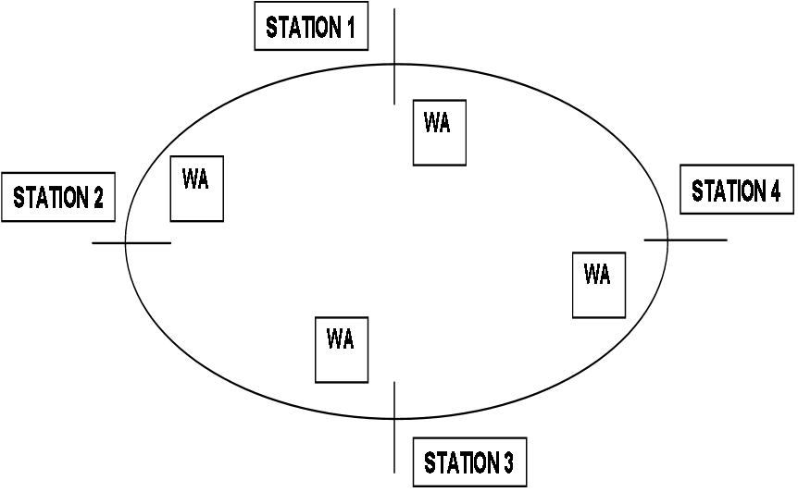
STATIONS

Scratch

Short Break 30 minutes

Event 12 Youth Scratch Race – Rolling Start (Omnium 3 of 3)

Event 14 | U7 Boys/Girls | 1 Lap
Event 15 | U9 Boys | 2 Laps
Event 16 | U9 Girls | 2 Lap
Event 17 | U11 Boys | 4 Laps
Event 18 | U11 Girls | 4 Laps
Event 19 | U13 Boys | 4 Laps
Event 20 | U15 Boys/Girl | 5 Laps

Fun Races depending on time while results are being calculated.

Prize Presentation and Close

