
Event: Schools National Hill Climb
Organisers: Solent Pirates Youth Cycling Club & Ditcham Park Cycling Club
Contact: Shaun Lawrence – ditchamhillclimb@yahoo.com, Mobile: 07834643381
Location: Ditcham Park School
Date: 18th June 2016
Time: Registration 0745 – 0945
Race 1000 – 1330.
Categories: U7/U9/U11/U13/U15/O15
Overview:
Ditcham Park School is the venue for the National Hill Climb 2016. We are expecting over 100 children to compete in this event. The hill climb is over a 2 miles course (shorter for younger riders), finishing at the school grounds. This is a semi closed road hill climb, well marshalled, and we always put the safety of the riders first.
B.S.C.A Rules of Racing 2016 apply
Personal Protection: Competitors must wear a helmet and gloves at all time.
Entry: Please complete the entry form and forward to: ditchamhillclimb@yahoo.com
Arrival & Registration:
It’s important that all attendees use the south drive entrance via Chalton village (PO8 0BG) to allow for the course to be reviewed and prepared for the morning racing. The school is sign posted from Chalton village. (School post code - GU31 5RN)
Entrance Via (South Drive)
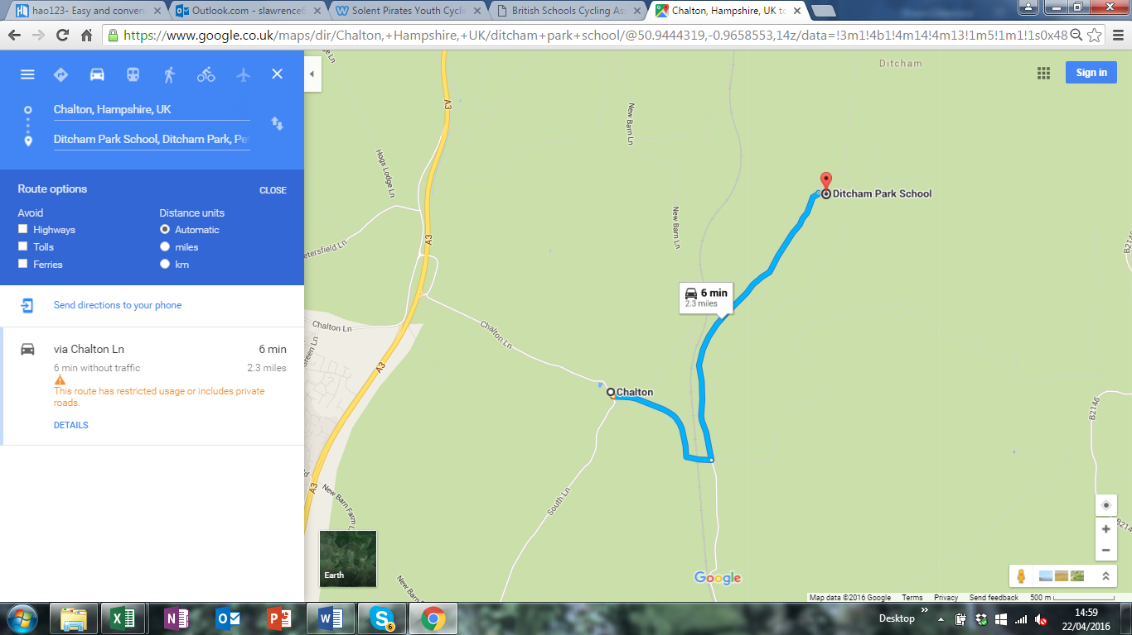
South Drive

Registration will be held in the Gym building on the first floor between 0745 to 0945. All registration to be completed by 0945, prior to first start.
Tents & Gazeebos: We would really appreciate your support in helping us to achieve a more social area by centralising all the schools club tents and gazeebos, outside of the Gym building, on the edge of the sports field.
Welfare: Changing facilities, toilets and refreshments will be available within the main Gym building. We are also planning a BBQ, at the end of the event (weather permitting!)

